TGSS
This graphics standard sucks
last updated 01/08/2025

Introduction

Welcome to TGSS – This Graphics Standard Sucks! If you thought VGA was bad, wait until you see this piece of shit. We're taking graphics standards to a whole new level of suckage with our incredible low resolutions, crappy colors, and borderline acceptable IO speeds. You won't find a better way to screw up your system than with TGSS.
We know there are plenty of other graphics standards out there, but this one is the best. Why? Because the IO ports start at 0x420, the funny weed number. That's why. The base model comes with a whopping 1MB of VRAM (yes, you read that right – 1MB!) This graphics card may not have any features or compatibility, but it has something even better - complete and total garbage performance. Framebuffer transfers are so slow, it's like you're watching paint dry in real time. And who doesn't want that? The ISA interface makes it theoretically compatible with a range of devices, from your ancient IBM PC to your shitty homebrew experiment.

With TGSS, you'll never have to worry about compatibility or performance again. Just plug in the video card, pray to God, and watch your system crash and burn. It’s that easy! Even the AI bot I tried to get to help with this wouldn’t stop complaining about how shit of an idea it was.

According to AI, it’s possible to run this card at a “1TB resolution”.

Still better than the Orange Pi 3B’s sorry excuse for a video chip. That shit can’t even run Blender at 800x600 any faster than 1 frame every 10 seconds.

Video ports

0x420 – vram bank register - R/W

Vram can be accessed in 128kb segments at memory address A0000-BFFFF. Register 0x420 is an 8 bit R/W register that contains vram bank numbers from 0-255. This can support up to 32mb of vram. While this may seem only semi-future proof, it is believed that if larger vram sizes are ever required, things will be different enough by then that it won’t matter.

Fuck it. Why not make it a 16 bit register. The pins exist for it. There. Now this video standard can support up to 8589803520 bytes. That’s 8.589803520 GB. 1000% future proof. That’s enough to build a 3d accelerated graphics card with 8gb of vram and ~590mb of internal ram all without using a different video standard.

0x421 – reserved

0x422 – video display register – R/W
bits 7-3 set the resolution. Bits 3-0 set the bit depth.
For bits 7-4, the options are:
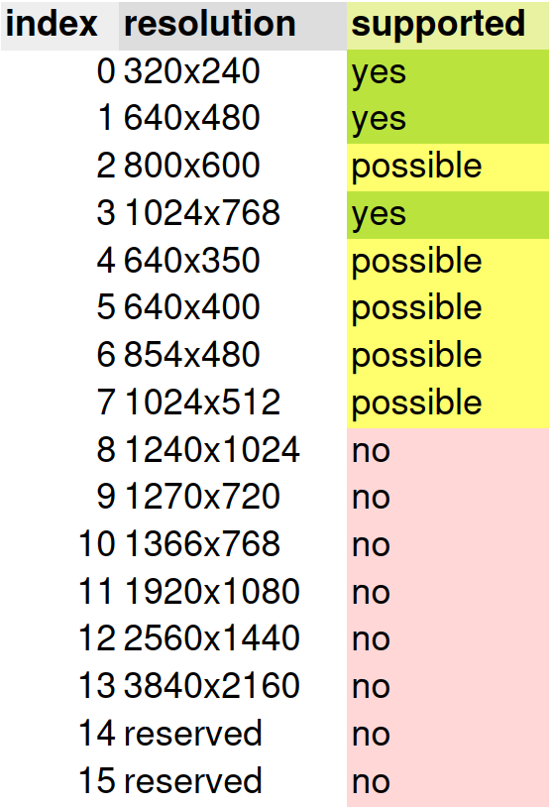

For bits 2-0, the bit depths are:
0=16 color
1=8 bit indexed color
2=16 bit color
3=24 bit color (reserved, not implemented)

0x423 – settings register – R/W
bit 7 = vga emulation (1 or 0)
bit 6 = 16 bit data bus mode (turning this off will cause a performance penalty)
bit 5 = enable screen (1 for on, 0 for off)
bit 4 = enable test pattern / disable vram (1 for regular operation, 0 for test pattern)
bit3-0 = reserved

0x424 – line draw index register – write only
0: color register
1: x1 pos high
2: x1 pos low
3: y1 pos high
4: y1 pos low
5: x2 pos high
6: x2 pos low
7: y2 pos high
8: y2 pos low

0x425 – line draw data register – write only

0x426 – status register
can be accessed any time even while ready is false
bit 7: output buffer full. 1 if full. 0 if not full.
bit 6: output buffer empty. 0 if not empty. 1 if empty
bit 5:input buffer full. 0 if not full. 1 if full
bit 4:readiness. 0 if still ready in 128 clock cycles. 1 if not
bit 3:readiness. 0 if still ready in 40 clock cycles. 1 if not
bit 2: readiness. 0 if still ready in 18 clock cycles. 1 if not
bit 1: readiness. 0 if still going to be ready in 4 clock cycles. 1 if not.
bit 0: ready. 0 if ready. 1 if not ready.

0x427 – data register – 8 bit or 16 bit
If running this video card alongside a vga card, the memory mapped io can’t be used. Instead, you have the option to use I/O ports to this. Writing an 8 or 16 bit value to this port will write that value to the location pointed to by 0x428 address pointer and 0x420 vram bank register. Reads can also be done.

0x428 – address pointer register – 8 bit or 16 bit
0x429 – 8 bit address register middle byte
0x42A – high byte for address register – 8 bit only
Memory mapped I/O – disabled by default upon bootup
Whatever byte or word you write to this while making a MEMW or SMEMW transfer to the video card between A0000-BFFFF will be written to that corresponding address. For example if register 0x420 contains the value 0x0000 and you use a SMEMW cycle to write a byte at address A0010, this will copy the byte to vram location 0x0010. If register 0x420 contains 0x0004 and you write a byte to SMEMW address 0xA50DF, the byte will go to vram address 0x8000A. Reading works the same as writing, MEMR and SMEMR read between A0000-BFFFF inclusive can read vram by pushing it onto the ISA bus for the host system’s isa chipset to deal with and send to the cpu.
Vram access works similarly to vram access on vga cards, it just doesn’t do that bit plane nonsense.

This mode is disabled by default in order to make it possible to run this video card alongside a vga video card.
Spi
This piece of shit also has a spi port. The 2 methods of testing include: spi or isa. Using spi is far less performant than using isa but it makes testing easier. Waiting for the bios to boot into ms-dos or c++ os each time you want to run the latest iteration of the test code is absolute ass poop so this feature makes it compatible with any spi interface that can be manually controlled.

Note that due to the way internal registers and clock dividers are set up, the spi sck frequency can be any number equal to or less than 6mhz. This means you can expect a maximum spi transfer rate of 600kbytes/sec. The isa interface can run at up to 8mbytes/sec on normal hardware and up to 40mbytes/sec if you do a bunch of hack-fucky bullshit. This was tested with the shitty slow ass gpio performance of a Orange Pi 3B which is something like 1000 bytes per second. It sucks ass.

The spi commands are as follows.
0x80 | device status | read only
bit 7: output buffer full. 1 if full. 0 if not full.
bit 6: output buffer empty. 1 if not empty. 0 if empty
bit 5:input buffer full. 0 if not full. 1 if full
bit 4:readiness. 0 if still ready in 128 clock cycles. 1 if not
bit 3:readiness. 0 if still ready in 40 clock cycles. 1 if not
bit 2: readiness. 0 if still ready in 18 clock cycles. 1 if not. | VSYNC*
bit 1: readiness. 0 if still going to be ready in 4 clock cycles. 1 if not. | HSYNC*
bit 0: ready. 0 if ready. 1 if not ready.
*if in special debug mode, these bits report the state of VSYNC and HSYNC

0xB0 | vram pointer address bits 0-7 | parameter size: 1 byte | write only
0xB1 | vram pointer address bits 8-15| parameter size: 1 byte | write only
0xB2 | vram pointer address bits 16-24 | parameter size: 1 byte | write only
0xB3 | video control flags | parameter size: 1 byte | read and write
bit 0: screen enable/disable.
bit 1: vram address pointer auto-increment. 0 to disable, 1 to enable.
bits 2-3: color depth, same as register 0x422 bits 2-3
bits 4-7: video mode, same as register 0x422 bits 4-7
0xB4 | vram data register| parameter size: 2 bytes | write only
currently the only 16 bit register. Put a 16 bit value into here and it gets copied to whichever location is being pointed to by address registers 0xB0, 0xB1 and 0xB2.
This register’s state after reset is 0x00.
The hardware and bus system

[block diagram image]

use ISA BALE signal to latch the ADS_LATCH signal on the 74LVC573APW chips. Basically just retransmit BALE, not even the inverted of BALE.

Assign ADS_LATCH = BALE; //this is pretty much it

get memory cycle information while BALE is high on MEMW, MEMR, IOR, IOW.

If a memory cycle happens while not ready, it asserts IORDY (ISA pin 41) until the bus is free.

CHRDY, ISA pin 32, is for NMI I/O error check stuff and can be safely ignored.

The U19 transceiver is used for normal 16 bit host to vram cycles as well as even byte aligned 8 bit transfers. The U18 is transceiver is used for odd byte aligned 8 bit transfers. If there was ever a situation where you needed an alignment-swapped 16 bit transfer, the U18 transceiver could be used for that as well.

The FPGA can assert the following ISA control signals: IO_RDY, MEMCS16, IOCS16, CHRDY and NOWS.
The FPGA can receive the following ISA control signals: SMEMW, SMEMW, MEMR, MEMW, IOR, IOW, SBHE, BALE and ISA_CLK. ISA_CLK is the ISA bus clock. It usually runs at 8MHz, but probably could run just fine in the range of 4MHz – 40MHz. Because of how host to VRAM cycles share the VRAM bus, there is a minimum speed that the ISA bus should run at that is yet to be determined, but probably higher than 4MHz.

The address bus has to be latched in order to be read. Some vintage x86 chipsets don’t leave the address bus active for the entire bus transfer cycle so this has to be done for compatibility. The slowest worst-case speed of the 74LVC575APW latches being used is 9.5ns/105.2MHz at 3.3 volts.

The slowest worst-case speeds of the 74LVC245 chips being used is 11.0ns/90.9MHz at 3.3 volts.

The slowest worst-case speeds of the 74ALVC16245 chips being used is 11.5ns/86.95MHz at 3.3 volts.

These chips should have no significant performance impact on an 8MHz ISA bus.

Using external latch chips makes it possible to save the address for later without actually having to clear the internal fpga vram address bus. This allows the host to initiate a transfer without interfering with any vram data copying that may be taking place.

